Disease Risk Prediction System

Project Id: PY-QT-65

Name : Samarth Tomer (Team Leader)
Class Roll Number: 65
University Roll Number : 2028834
Section and Group: Q G2

Name : Sparsh Saxena
Class Roll Number: 70
University Roll Number : 2028864
Section and Group: Q G2

Name : Tanmay Kumar
Class Roll Number: 72
University Roll Number : 2028879
Section and Group: Q G2

INDEX

- Problem Description 3
- Architecture 4
- Models model 5
- Evaluation metrics used 6
- Preliminary Results and Visualizations 7
- References 8

- Problem Description

The Disease Risk Prediction System is a machine learning-based classification project designed to predict the likelihood of heart disease in patients using clinical data.
The system uses a dataset containing various medical attributes such as age, sex, chest pain type, blood pressure, cholesterol level, maximum heart rate, and other diagnostic measurements. Two datasets were used in this project: a raw dataset and a cleaned dataset after preprocessing.
The objective of this project is to build predictive models that can classify whether a patient is at risk of heart disease (target = 1) or not (target = 0).
To ensure high-quality predictions, the system performs:
- Data cleaning to handle missing and inconsistent values
- Data transformation and normalization for better model performance
- Feature selection to identify the most important medical attributes
Three machine learning algorithms — Logistic Regression, K-Nearest Neighbours (KNN), and Support Vector Machine (SVM) — are trained and compared.
The models are evaluated using performance metrics such as accuracy, precision, recall, F1-score, confusion matrix, and ROC curve.
This system can assist in early detection of heart disease and support medical decision-making using data-driven insights.

- Architecture

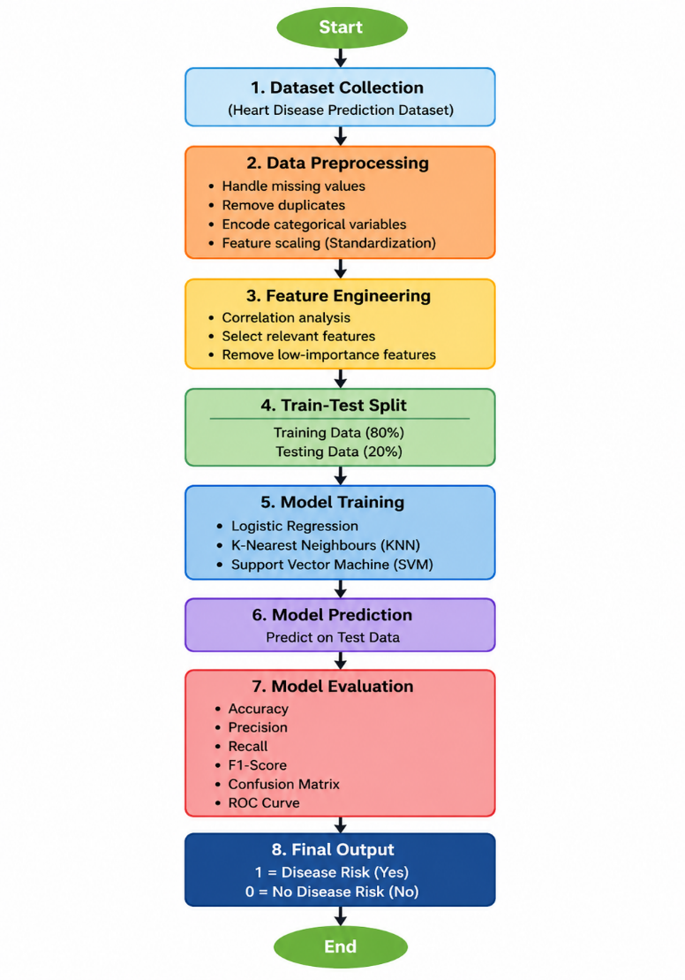

The flowchart represents an end-to-end machine learning pipeline for predicting disease risk using clinical data. It includes data preprocessing, feature selection, model training using Logistic Regression, KNN, and SVM, and performance evaluation using metrics such as accuracy, precision, recall, F1-score, confusion matrix, and ROC curve. The final output classifies patients into disease risk categories.

- Models Used(Applied/ Planned) Give a brief introduction of the models used

In this project, three supervised machine learning classification algorithms are applied to predict the risk of heart disease based on clinical data.

Logistic Regression
Logistic Regression is a statistical classification algorithm used for binary outcomes. It predicts the probability of a patient having heart disease using a sigmoid (logistic) function. It is simple, efficient, and provides easily interpretable results, making it suitable for medical prediction tasks.

K-Nearest Neighbours (KNN)
KNN is a non-parametric, instance-based learning algorithm that classifies a data point based on the majority class of its nearest neighbors. It uses distance metrics such as Euclidean distance to determine similarity. The performance of KNN depends on the choice of the number of neighbors (K) and works well for pattern recognition.

Support Vector Machine (SVM)
SVM is a powerful classification algorithm that identifies the optimal hyperplane to separate different classes. It can handle both linear and non-linear data using kernel functions. SVM is effective in high-dimensional spaces and is known for its high accuracy and robustness.

These models are selected to compare performance across linear, distance-based, and margin-based learning approaches.

- Evaluation metrics used

To evaluate the performance of the machine learning models used for disease prediction, several standard classification metrics are applied. These metrics help in understanding the effectiveness of the models from different perspectives.

Accuracy
Accuracy measures the overall correctness of the model by calculating the proportion of correctly predicted instances out of the total instances.
$$Accuracy=\frac{TP+TN}{TP+TN+FP+FN}$$
Precision
Precision indicates the proportion of correctly predicted positive cases out of all predicted positive cases. It is important when false positives need to be minimized.
$$Precision=\frac{TP}{TP+FP}$$
Recall (Sensitivity)
Recall measures the ability of the model to correctly identify actual positive cases. It is crucial in medical applications where missing a disease case can be critical.
$$Recall=\frac{TP}{TP+FN}$$
F1-Score
F1-Score is the harmonic mean of precision and recall. It provides a balance between the two metrics, especially when the dataset is imbalanced.
$$F1=2×\frac{Precision×Recall}{Precision+Recall}$$
Confusion Matrix
A confusion matrix is a tabular representation of model performance showing:
- True Positives (TP)
- True Negatives (TN)
- False Positives (FP)
- False Negatives (FN)

It helps in visualizing the classification performance in detail.
ROC Curve (Receiver Operating Characteristic Curve)
The ROC curve is a graphical representation of the model’s ability to distinguish between classes. It plots the True Positive Rate (Recall) against the False Positive Rate. A model with a higher Area Under Curve (AUC) indicates better performance.

These evaluation metrics provide a comprehensive assessment of model performance, especially in healthcare applications where both false positives and false negatives are critical.

5. Preliminary Results and Visualizations

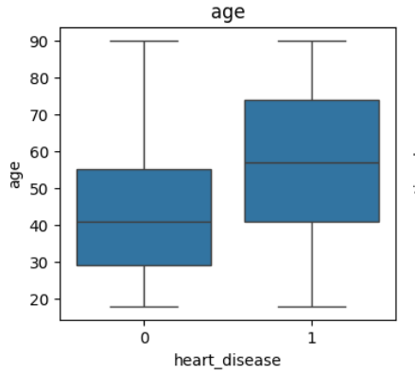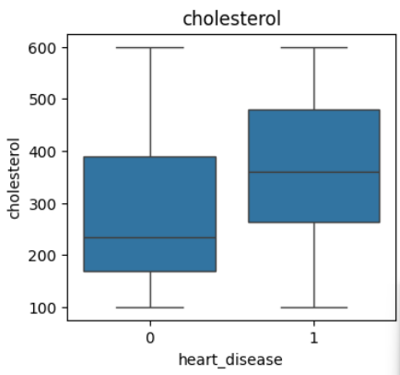

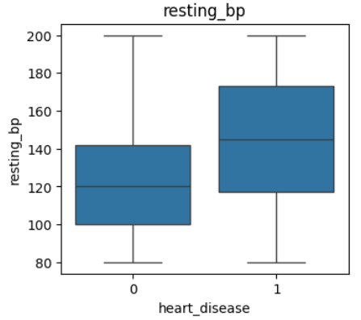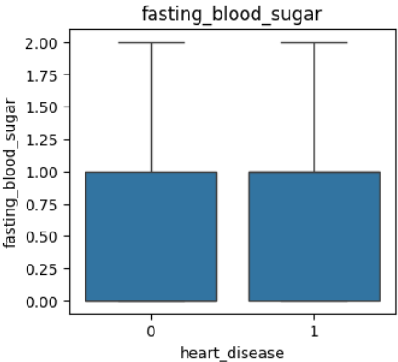

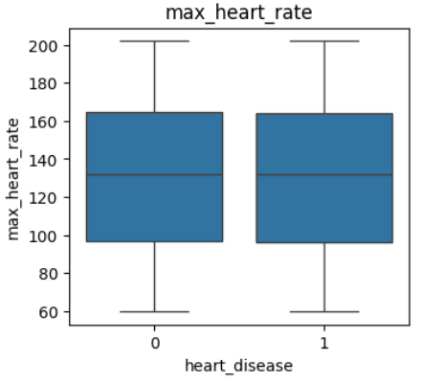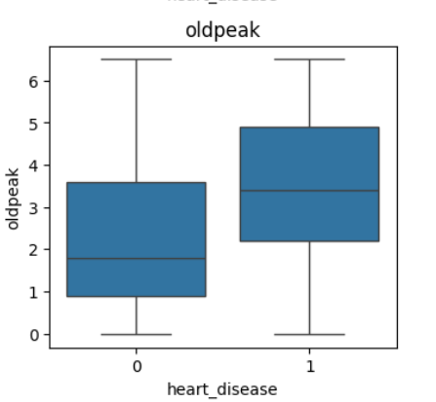

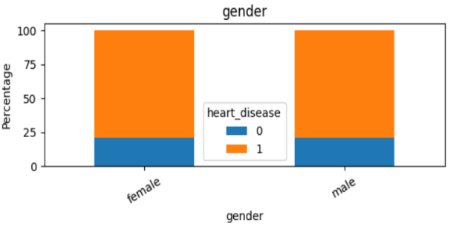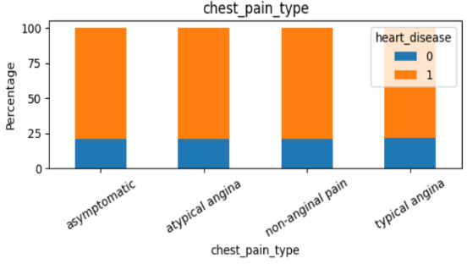

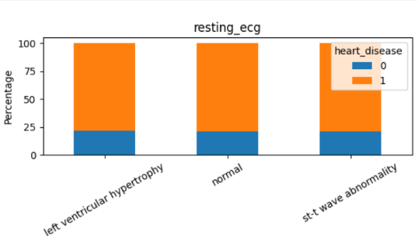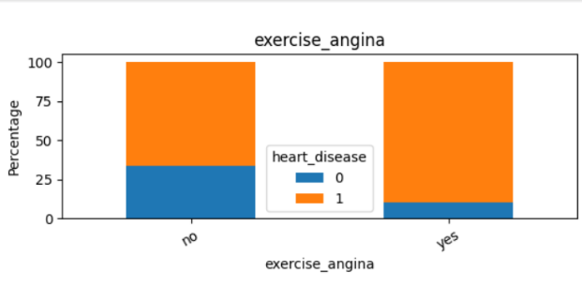

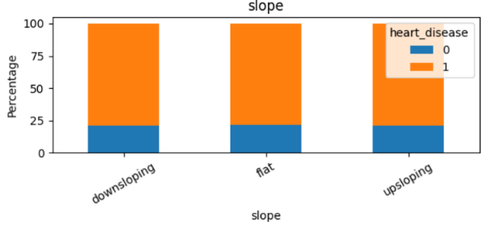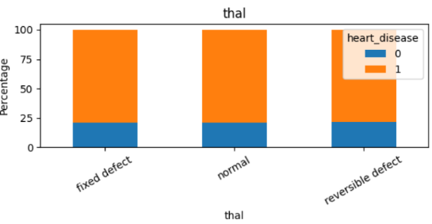

6. References:
Books:
- Let Us Python – Yashavant Kanetkar

Online Resources:
  - GeeksforGeeks – https://www.geeksforgeeks.org/
  - TutorialsPoint – https://www.tutorialspoint.com/cprogramming/index.htm
  - Stack Overflow – https://stackoverflow.com

